**The cleaning process**

**First, when I opened the file I found some issues in the release date that there are some cells aren’t formatted well as the others, and we need to convert the time’s cells to number of minutes**

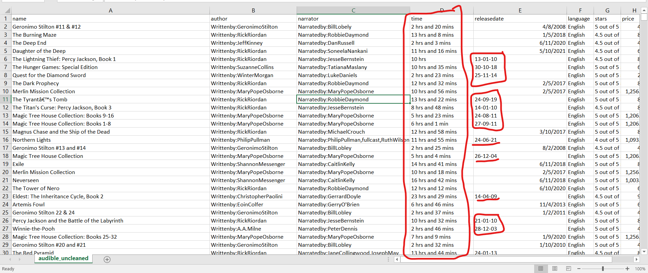

**Well, for release date, first went to an empy cell, typed the date manually as below**

=DATE(RIGHT(E6,2)+2000,MID(E6,4,2),LEFT(E6,2))

**I Cut the the numbers from the cell manually and then I pull it to apply it to all cells**

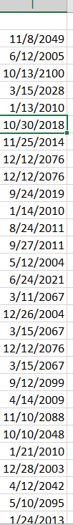

**Well, there is cells the year of it is 2076 and this is not correct but bare with me, now, I will change the release date format to number**

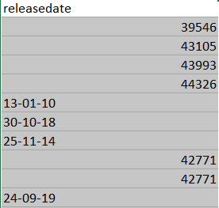

**You see that the correct date changed to number but the not corrected ones didn’t, now I went to an empy cell then typed**

**=ISNUMBER(E2)**

**And pulled it to be applied to the all cells below.**

**The True value mean that the this is date, false mean that this isn’t a date, went to an empty cell the typed this IF formula:**

**=IF(J2= TRUE,E2,I2)**

**and pulled it to all cells**

**This means that if the cell J2 equals to TRUE this means that this is a date, put the e2 date in here, but if FALSE then put the I2 Cell(the DATE formula I Typed previously), now the last version is**

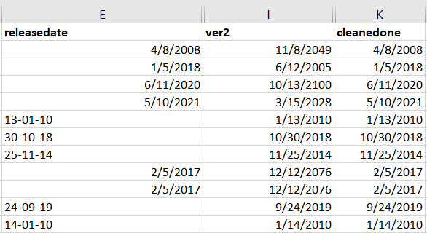

**The last version is “cleanedone”.**

**And for the total minutes for every cell I’ve to extract the hours alone and the the same thing with the minute, for the hours column I’ll use his:**

**=IF(ISNUMBER(SEARCH("hrs",D2)),LEFT(D2,2),0)**

**I search If the “hrs” string in the cell D2 then it has hours in it, well, the minutes column will be like this**

**IF(ISNUMBER(SEARCH("mins",D2)),LEFT(RIGHT(D2,7),2),0)**

**If it has “mins” string in it so it has minutes, I’ll extract it then with left and right functions**

**And the total minutes will be like this**

**=I2*60+J2**

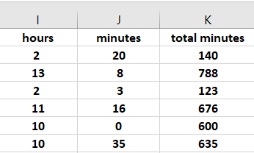

***The last result***

**For the rating column I used the Replace feauture And Deleted thes strings “out of 5 stars” ,”ratings” and “rating”, then used the below**

**=IF(ISNUMBER(SEARCH("not rated",G2)),"non",TRIM(RIGHT(G2,4)))**

**And for the rate column:**

**=IF(ISNUMBER(SEARCH("not rated",G2)),"non",TRIM(LEFT(G2,3)))**

**And this is the result:**

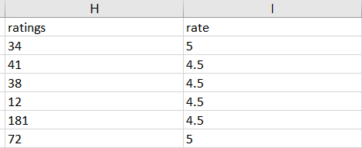

**The price Column Didn’t changed too much, just formatted it as currency**

**Conclusion**

**As You Arrived here means you read it all and I appreicate this, the hard thing was the time column and I’ve showed you Step-by-step how I’ve Done it, Thanks.**